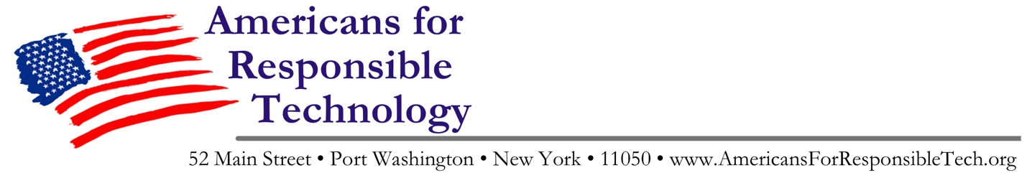

Press Advisory/Release

Who: Individuals that share science-based health concerns about 5G
What: 5G National Day of Action rallies
When: Saturday, July 27th
Where: In cities, towns and communities across America
Why: Science links exposure to wireless radiation with human health problems

Background:

This weekend, a broad coalition of community-based organizations opposed to the widespread deployment of 5G-enabled "small cell" microwave antennas is sponsoring informational rallies in towns and cities across America. The goal is to educate neighbors and push back against the rollout of 5G technology which will result in the involuntary exposure of hundreds of millions of Americans to unsafe levels of wireless radiation without their knowledge or consent.

The groups, a loose association under the banner of Americans for Responsible Technology, are citing hundreds of published, peer-reviewed studies that link long-term exposure to wireless radiation with significant biological harm, even at levels deemed safe by the Federal Communications Commission (FCC).

"This isn't speculation, this is science," says David McAllister, one of the organizers of the rallies. "While the wireless companies are breathlessly telling everyone how great their lives will be with 5G, scientists and public health experts are genuinely concerned that constant, involuntary exposure to microwave radiation will result in a serious public health crisis, and that children will be affected most."

More information at AmericansForResponsibleTech.org and 5GCrisis.com

